17.50: a) 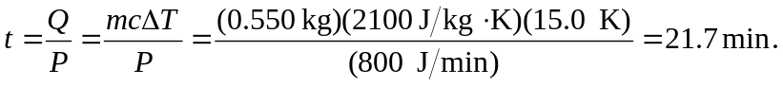

b) 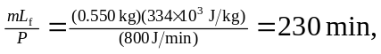so the time until the ice has melted is

